B
U
S
I
N
E
S
S

A
N
A
LY
T
I
C
S

R
E
P
O
R
T
TELECOM CUSTOMER CHURN
Exploratory Data
Analysis & Retention
Strategy
A data-driven breakdown of churn behaviour across 7,043
customer records, translating patterns into prioritised retention
strategy.
26.54
%
OVERALL CHURN RATE
Prepared by Fatima Moeen
BSc (Hons) Computer Science, Jamia Millia Islamia
Dataset: 7,043 records · 20 features
Python (Pandas, Matplotlib, Seaborn)

Table of contents

01 Executive Summary

02 Interactive Dashboard Snapshot

03 Business Context & Objectives WHY THIS MATTERS

04 Overall Customer Churn Distribution

05 Churn Analysis by Senior Citizen & Gender WHO'S LEAVING

06 Tenure & the Early-Churn Risk Window WHEN THEY LEAVE

07 Bottleneck Detection: Service & Account Drivers WHY THEY LEAVE

08 Financial Profile of Churned Customers WHAT IT COSTS

09 Methodology & Data Source

10 Strategic Recommendations WHAT TO DO ABOUT IT

01 EXECUTIVE SUMMARY

Executive summary
This report presents an exploratory data analysis of customer churn for a telecom service provider, covering 7,043 customer records across 20 demographic, account, and serviceusage features. The objective is to identify which customer segments and service patterns are most strongly associated with churn, and to translate those patterns into specific, actionable retention strategies.
The headline finding: 26.54% of customers in the dataset have churned. Churn concentrates heavily among customers on month-to-month contracts, those paying via electronic check, customers without tech support or online security add-ons, and customers in their first few months of tenure. Senior citizens churn at nearly double the rate of nonsenior customers, while gender shows almost no correlation with churn behaviour.
Financially, churned customers carry higher average monthly charges (~$74) than retained customers (~$61) — meaning the customers most likely to leave are also the ones generating above-average revenue, which raises the retention stakes further.
OVERALL CHURN RATE
26.54
%
1
in 4 customers leave the service
HIGHEST RISK SEGMENT
Month-to-month
42.7
% churn — contract type is the strongest
single driver
BIGGEST REVENUE RISK
$74 vs $61
churned customers pay more monthly than
retained ones
TOP RECOMMENDATION
Contract conversion
critical priority — offer incentives off month-to-
month
02
SEE IT LIVE

Interactive dashboard snapshot
The findings in this report are also available as an interactive Tableau dashboard, allowing filtering by gender and senior citizen status across all seven churn dimensions covered below.
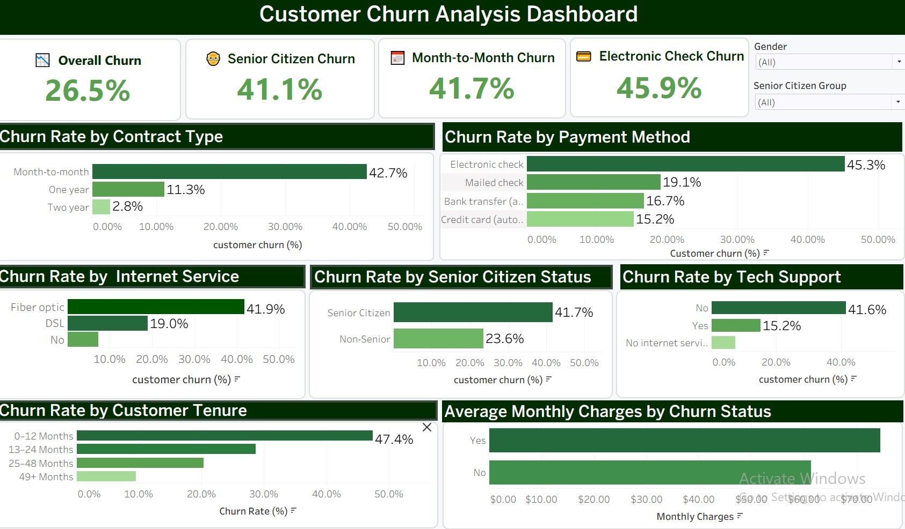
Fig 0. Tableau dashboard — customer churn analysis

03
WHY THIS MATTERS

Business context & objectives
Customer churn — the rate at which customers discontinue service — directly erodes recurring revenue and increases customer acquisition costs, since replacing a lost customer is consistently more expensive than retaining an existing one. For a subscription-based telecom business, even a few percentage points of churn reduction compounds significantly across a customer base of this size.

Objectives
Quantify the overall churn rate and identify which customer segments churn most.
Determine which service offerings, contract types, and payment methods correlate with higher churn.
Assess the financial exposure created by churn and the charge profile of at-risk customers.
Translate findings into prioritised, actionable retention recommendations.

04 THE HEADLINE NUMBER

Overall customer churn distribution
26.54% of customers have churned, while 73.46% remain retained.
Approximately 1 in 4 customers leave the service, indicating a notable churn rate.
Targeted retention strategies can help reduce churn and improve customer loyalty.
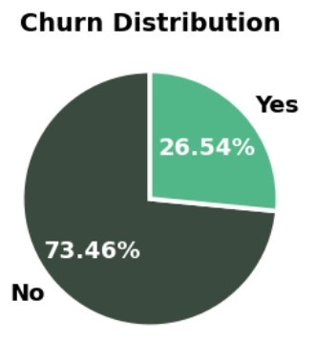
Fig 1. Churn vs retention split, full customer base (n = 7,043)

05
WHO'S LEAVING

Churn analysis by senior citizen & gender

Churn based on gender
Male and female customers exhibit nearly identical churn rates.
Gender has minimal impact on customer churn behaviour.
Other factors such as contract type, tenure, and monthly charges are likely stronger churn drivers.
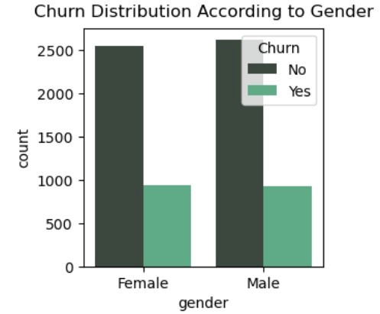
Fig 2. Churn distribution by gender

Churn based on senior citizen status
Non-senior customers form the majority of the customer base and show lower churn overall.
Senior citizens have a comparatively higher likelihood of churning despite being fewer in number.
Among senior citizens, churn patterns are similar for both males and females, indicating gender has little influence on churn.
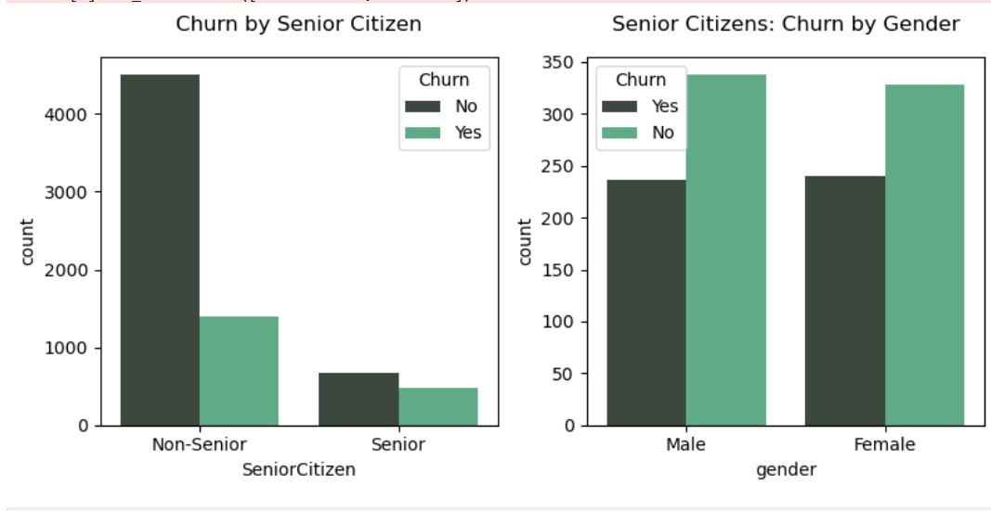
Fig 3. Churn distribution by senior citizen status

06
WHEN THEY LEAVE

Tenure & the early-churn risk window
Customers with very low tenure (0–3 months) have the highest churn, indicating earlystage customer dissatisfaction.
Churn decreases as tenure increases, showing that long-term customers are more likely to stay loyal.
Customers with 70+ months of tenure have the highest retention and the lowest churn rate.
The distribution suggests that customer loyalty strengthens over time, reducing the likelihood of churn.
The first few months are the most critical period for retention efforts, making onboarding and engagement essential.
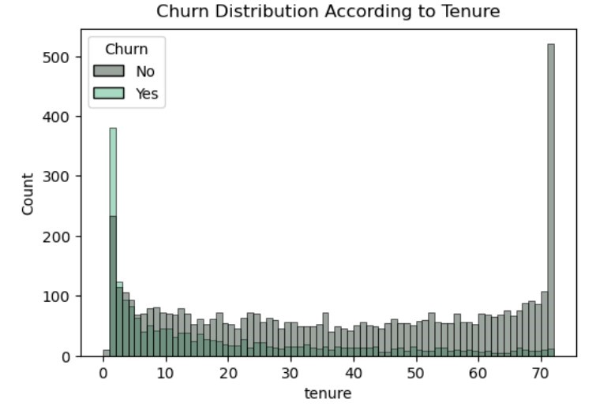
Fig 4. Churn rate across tenure bands

07
WHY THEY LEAVE

Bottleneck detection: service & account drivers
This is the most actionable section of the analysis. Twelve service and account attributes were tested against churn. The patterns are consistent and economically intuitive: customers with month-to-month flexibility, no add-on protections, and manual payment methods churn far more than customers locked into longer contracts with bundled services and automatic payments.
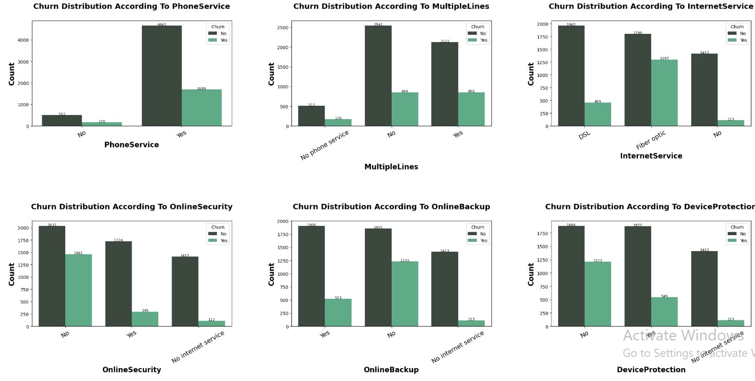
Fig 5. Churn by tech support, streaming TV, and streaming movies
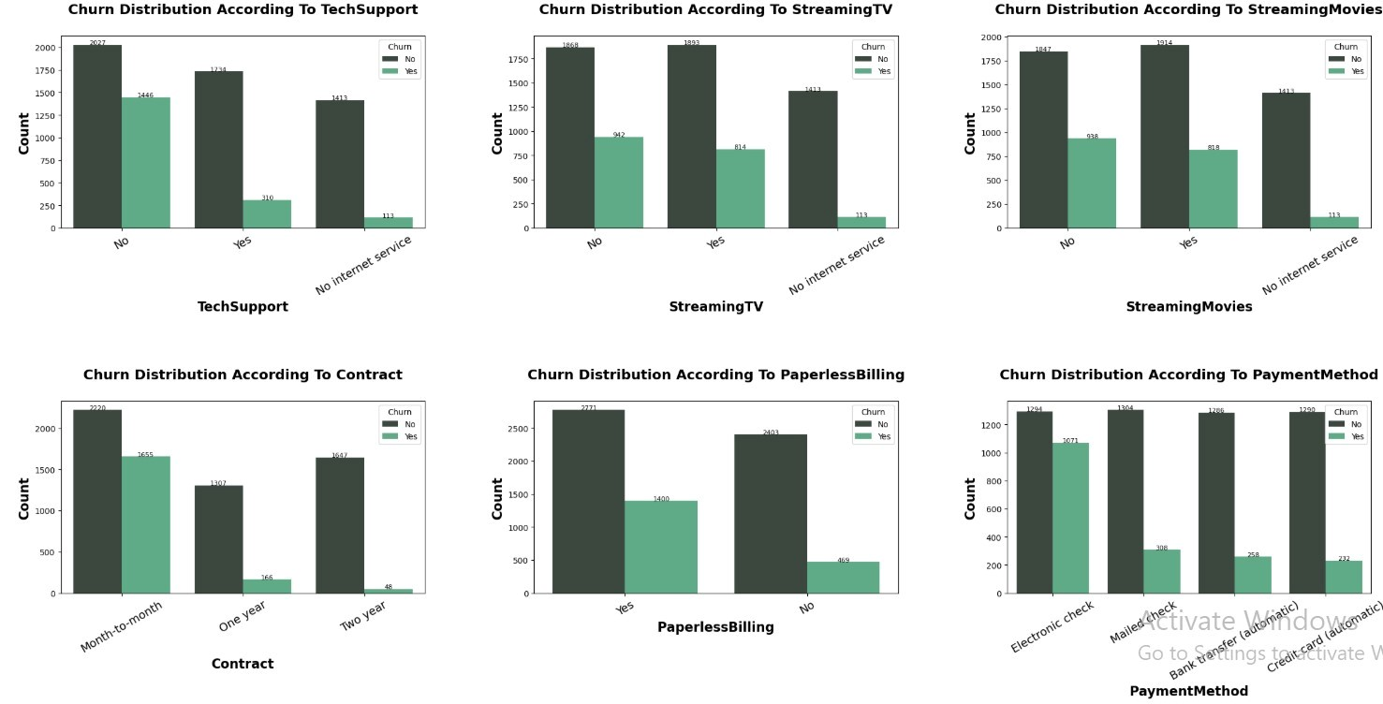
Fig 6. Churn by contract type, paperless billing, and payment method

Highest-impact drivers (ranked)
Attribute | Highest-risk group | Approx. churn rate
Contract type | Month-to-month | 42.7%
Internet service | Fiber optic | 41.9%
Tech support | No tech support | 41.6%
Online security | No online security | 41.8%
Payment method | Electronic check | 45.3%
Paperless billing | Enabled | 33.6%
By contrast, customers on two-year contracts churn at just 2.8%, and those with online security or tech support add-ons churn at roughly 14–15% — a three-fold reduction versus customers without those protections. This gap is the clearest lever available for retention strategy.

08
WHAT IT COSTS

Financial profile of churned customers

Impact of monthly charges on customer churn
Customers who churn ("Yes") have significantly higher average monthly charges (~$74) than those who stay (~$61).
Higher monthly charges are strongly associated with increased customer churn.
Reducing perceived cost or offering better-value plans may help lower churn among highpaying customers.
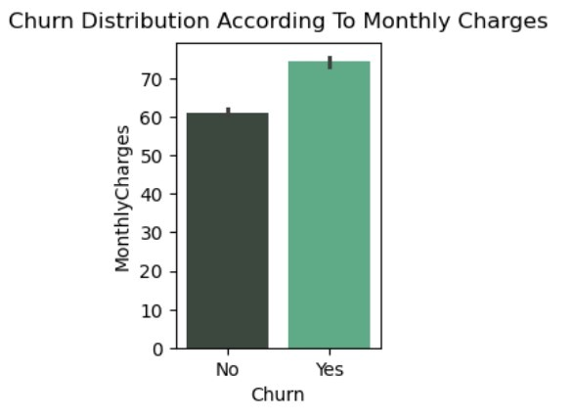
Fig 7. Monthly charges distribution — churned vs retained

10 WHAT TO DO ABOUT IT

Strategic recommendations
Based on the findings across all analytical dimensions, the following prioritised actions are recommended:

IMMEDIATE
1
Launch contract-conversion incentive
CRITICAL
Month-to-month customers churn at 42.7% vs 2.8% for two-year contracts. Offer 1–2 months free or
a discounted rate for switching to a 1-year contract — this segment represents the single largest
concentrated churn risk.
2
Build a 90-day onboarding retention track
HIGH
Churn is heavily concentrated in months 1–3 of tenure. Deploy proactive check-ins, usage tutorials,
and an early-tenure discount to bridge customers through this highest-risk window.
3
Target senior citizen customers
HIGH
Senior citizens churn at ~42% vs ~24% for non-seniors. Introduce a dedicated support line or
simplified billing communication for this segment.

MEDIUM TERM
4
Bundle online security & tech support
MEDIUM
These add-ons show the strongest correlation with retention after contract type — churn drops to 14–
15
% with them vs ~42% without. Bundle into mid-tier plans by default or offer free for the first
3
months.
5
Investigate fiber optic dissatisfaction
MEDIUM
Fiber optic churn (41.9%) nearly matches month-to-month contract churn. Audit pricing, reliability, and
competitive pressure specific to this service line.
6
Shift electronic check users to automatic payment
MEDIUM
Electronic check carries the highest churn rate of all payment types (45.3%). Use small incentives to
migrate users to bank transfer or credit card autopay.

LONG TERM
7
Build a churn-propensity scoring model
LOW
Use logistic regression or Random Forest with tenure, contract, internet service, and add-on flags as
primary features to flag at-risk customers proactively rather than reactively.
8
Establish a quarterly churn-driver review
LOW
Track whether interventions above are shifting the distributions identified in this report, using the
same analytical framework each quarter.

09 HOW THIS WAS BUILT

Methodology & data source
Dataset
Telco Customer Churn dataset — 7,043 customer records, 20 demographic, account, and service-
usage features, plus the churn label.
Tools
Python (Pandas for cleaning and aggregation, Matplotlib/Seaborn for visualisation), Jupyter Notebook
for the exploratory analysis.
Approach
Univariate and bivariate exploratory analysis — churn rate cross-tabulated against each categorical
and numerical feature, ranked by effect size to surface the highest-impact drivers.

